**LEBANESE AMERICAN UNIVERSITY**

**USAID – HIGHER EDUCATION SCHOLARSHIP PROGRAM**

**HES - Volunteering Program Verification Form**

This form is to be used to document volunteering hours. If a student volunteers for multiple organizations, a separate form must be used for each organization. **This form must be turned in by the 28th of each month, the latest.**

I certify that the scholar Danielle Mikhael completed a total of 20 hours of service at InnovaThrive.

The hours were completed hours as per the below:

Hours # 5 (date) _2/12 – 6/12_ (initials of supervisor) __A.K.___

Hours # 5 (date) _9/12 – 13/12_ (initials of supervisor) __A.K.___

Hours # 5 date) _16/12 – 20/12 (initials of supervisor) __A.K.___

Hours # 5 date) _23/12 - 27/12 (initials of supervisor) __A.K.___

Brief description of the activities the scholar performed or participated in:

Throughout my tenure as CEO Advisor at InnovaThrive, I worked closely with the CEO and his office to address key challenges, streamline workflows, and enhance organizational effectiveness. My role required proactive problem-solving and the ability to devise comprehensive solutions to complex issues while maintaining alignment with the organization’s strategic goals. I collaborated with key stakeholders to craft actionable plans and ensured their prompt execution, fostering a culture of accountability and cooperation. A core aspect of my duties was to enhance the volunteer experience by introducing structured onboarding, clear communication practices, and recognition initiatives that boosted engagement and satisfaction. In addition to addressing immediate organizational needs, I supported the CEO and his office in strategic planning, performance evaluation, and project oversight, ensuring that all initiatives were executed efficiently and with measurable outcomes. By maintaining open communication, driving innovative solutions, and focusing on sustainable improvement, I was able to contribute meaningfully to the organization’s growth and its commitment to excellence.

Written feedback about the scholar’s performance:

Danielle is an outstanding individual whose contributions to InnovaThrive have demonstrated her dedication, initiative, and exceptional capabilities. She is a proactive team player who consistently approaches challenges with a solution-oriented mindset and works diligently to ensure the success of her tasks and responsibilities.  
  
Her ability to collaborate effectively with others, combined with her strong organizational and communication skills, makes her a valuable asset to any team she is part of. Danielle is also deeply committed to her personal and professional growth, always eager to take on new challenges and opportunities for learning.  
  
Danielle is not only a hard-working and adaptable professional but also a positive influence on her peers, fostering an environment of cooperation and mutual respect. I have no doubt that her strong work ethic, leadership qualities, and dedication will greatly contribute to her success in her scholarship and future endeavors.

Please rate the overall performance of the scholar at your organization:

|  |  |  |  |
| --- | --- | --- | --- |
|  | Mastery (5) | Proficient (3) | Emerging (1) |
| **Problem solver** | X |  |  |
| **Engaged & Committed** | X |  |  |
| **Open-minded & multicultural** | X |  |  |

Signature

& stamp

__________________________

_

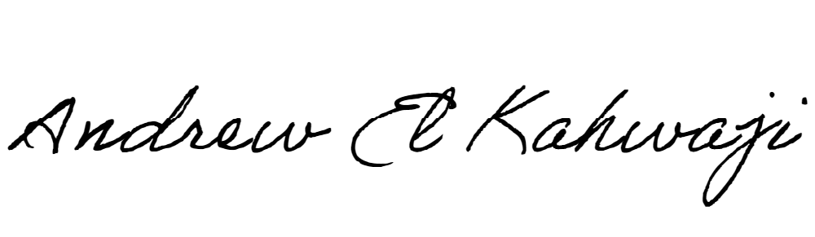

Printed Name _Andrew El Kahwaji_

Date __26/12/2024___

Email __andrew.lifesculptor.coo@gmail.com __

Phone __+961 71 914 378__